Interim Forensic Report
Triage Forensic examination of the suspects computer has identified the following information in screenshots and images relating to Western Union:
- Artefact recovered of an attempted transfer of funds to Turkey:
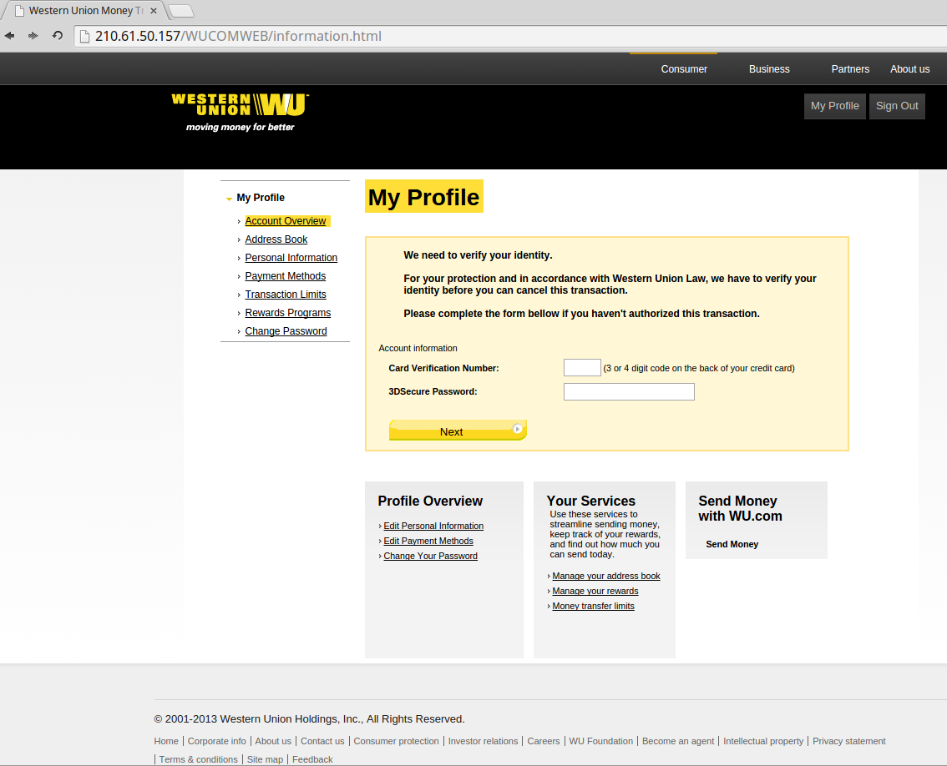
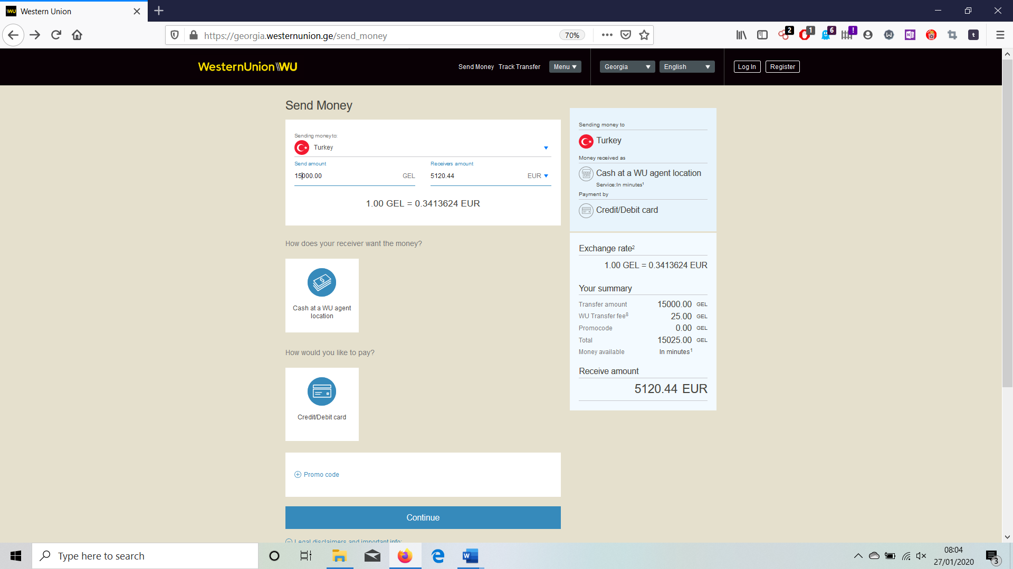

Indications of money transfer via Western Union

